**Definition of continuity at a point**

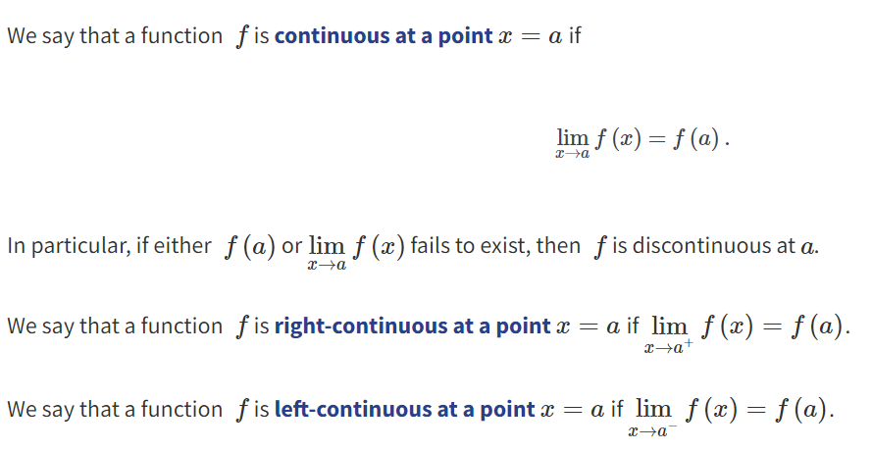

**Types of Discontinuities**

It is sometimes useful to classify certain types of discontinuities.

Jump discontinuity

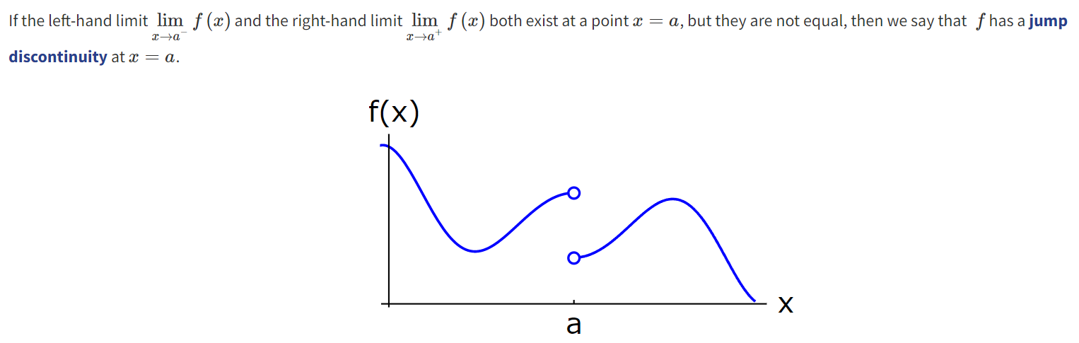

Removable discontinuity

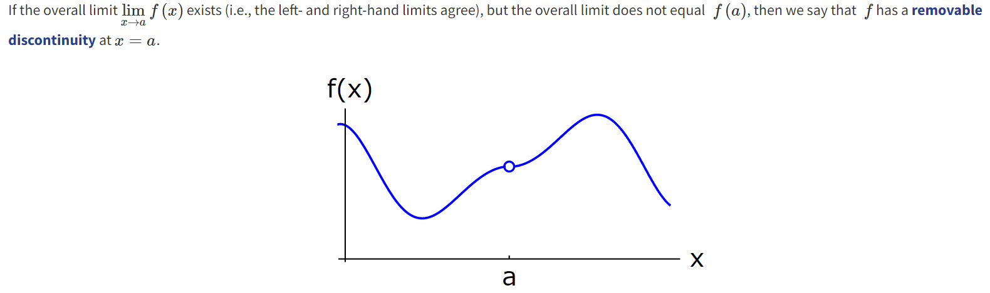

**Definition of continuous functions**



**Basic Continuous Functions**

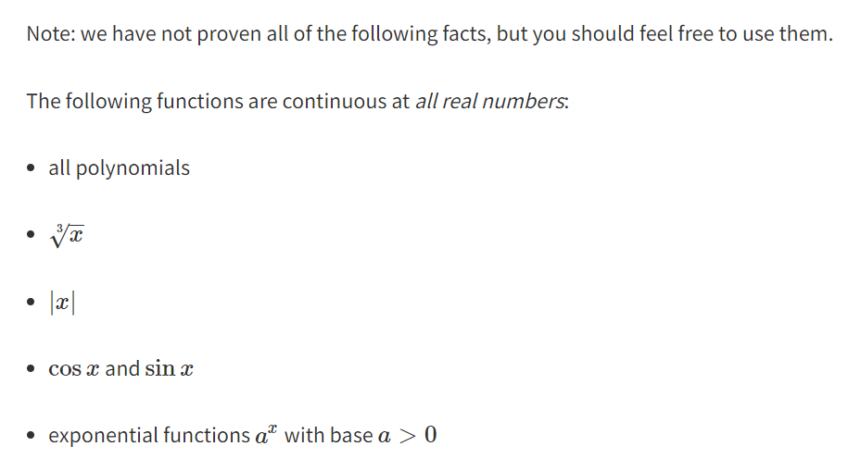

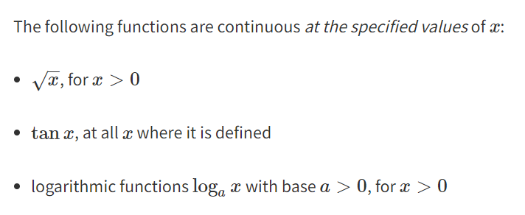

**Limit laws and continuity**

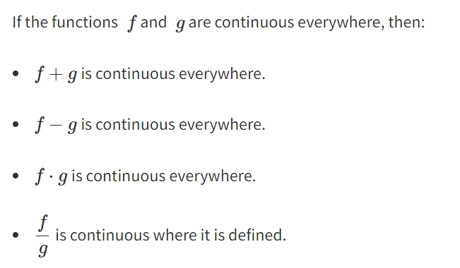

**Intermediate Value Theorem**





* Using this, we can conclude about the roots of a function by using M = 0 depending on how many point C’s it produced (every point that intersected when M=0)